**How to Use the Interactive map Locally?**

1. Install Latest Version of Python. - https://www.python.org/downloads/
2. Download the folder (Preferably Desktop)
3. Open the Folder and copy the path.

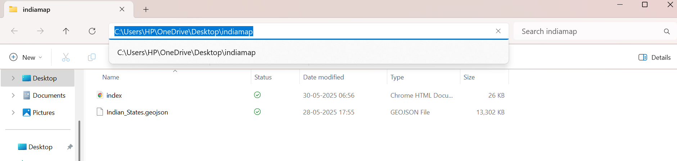

1. Now open cmd (command prompt) and then type “cd” and paste the path you copied.
2. Next type: python -m http.server and you’ll get this.

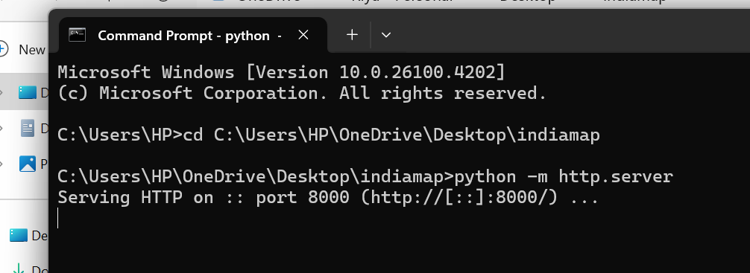

1. Finally go to your Google Chrome and then type localhost:8000 and your map gets opened.

